Widgets / Plugins

Definition:
# Source: AI Source: Provided by: [Data Path: Persons Table -> ID Column: 1, Name_En Column: Motasem Essam] -> From: [Chatgpt (GPT‑5 Mini)] on [2/12/2026]
Widgets / Plugins are web page components that add extra functionality or features to a website beyond the standard content. They are often pre-built tools that can be easily integrated.

Simple Definition
# Source: AI Source: Provided by: [Data Path: Persons Table -> ID Column: 1, Name_En Column: Motasem Essam] -> From: [Chatgpt (GPT‑5 Mini)] on [2/12/2026]
Widgets / Plugins = small applications or tools on a web page that provide extra features, like maps, social feeds, or calendars.

What Widgets / Plugins Usually Include
# Source: AI Source: Provided by: [Data Path: Persons Table -> ID Column: 1, Name_En Column: Motasem Essam] -> From: [Chatgpt (GPT‑5 Mini)] on [2/12/2026]
- Interactive tools – calendars, polls, calculators, weather updates
- Embedded content – social media feeds (Facebook, Twitter, Instagram)
- Media players – video or audio players
- Forms / Chatbots – contact forms, live chat support
- E-commerce features – product sliders, currency converters

Purpose of Widgets / Plugins
# Source: AI Source: Provided by: [Data Path: Persons Table -> ID Column: 1, Name_En Column: Motasem Essam] -> From: [Chatgpt (GPT‑5 Mini)] on [2/12/2026]
- Add functionality without coding from scratch
- Enhance user experience and engagement
- Provide interactive or dynamic content
- Integrate external services (maps, social media, payment systems)

Examples
# Source: AI Source: Provided by: [Data Path: Persons Table -> ID Column: 1, Name_En Column: Motasem Essam] -> From: [Chatgpt (GPT‑5 Mini)] on [2/12/2026]
- Google Maps widget → shows location on a contact page
- Social media feed → latest Instagram or Twitter posts
- Live chat → customer support pop-up
- Calendar plugin → schedule appointments or events

Difference Between Widgets / Plugins and Forms
# Source: AI Source: Provided by: [Data Path: Persons Table -> ID Column: 1, Name_En Column: Motasem Essam] -> From: [Chatgpt (GPT‑5 Mini)] on [2/12/2026]
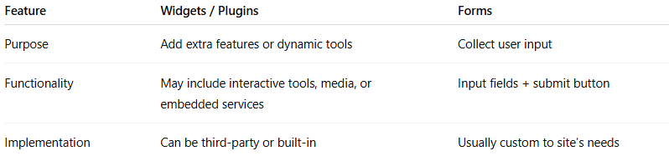
Feature | Widgets / Plugins | Forms
Purpose | Add extra features or dynamic tools | Collect user input
Functionality | May include interactive tools, media, or embedded services | Input fields + submit button
Implementation | Can be third-party or built-in | Usually custom to site’s needs

